

Student Management System
Project Report
Course: OOP using JAVA
Names:
- YUMVAGUSENGA Ange 224014529
- IGIRANEZA Kevin 224005430

Technologies: Java Swing, SQLite, JDBC, NetBeans

Github link: https://github.com/angeyumva/Student-Management-System-in-Java.git

1. Introduction
The Student Management System (SMS) is a desktop-based Java application developed to manage student records through a graphical user interface. The system provides a login page, a main management page, SQLite database storage, and the core CRUD operations needed to add, update, delete, search, and display student information.
This report explains the current state of the submitted project, the technologies used, the file structure, implemented features, validation rules, test data, and requirement compliance.

3. Objectives of the Project
- Design a Java Swing application that stores and manages student records.
- Connect the application to an SQLite database using JDBC.
- Implement the main CRUD operations: add, update, delete, search, and display all students.
- Apply input validation and simple rules such as preventing marks above 100.
- Organize the project into logical packages and collaborate through GitHub branches and commits.

4. Development Environment and Tools
Tool / Technology | Use in the project
Java | Core programming language used to implement the application logic.
Java Swing | Used to create the login page, main form, menu bar, buttons, fields, labels, combo boxes, and table.
NetBeans IDE | Used to design the GUI with the Swing UI Designer and manage the project structure.
SQLite | Lightweight local database used to store student records in students.db.
JDBC | Used to connect Java classes to the SQLite database and execute SQL commands.
Git and GitHub | Used for version control, branching, and project submission with two branches (main and ange).
5. Project Structure
The submitted project follows a package-based structure that separates the data access, model, and user interface layers. This makes the project easier to read, maintain, and extend.
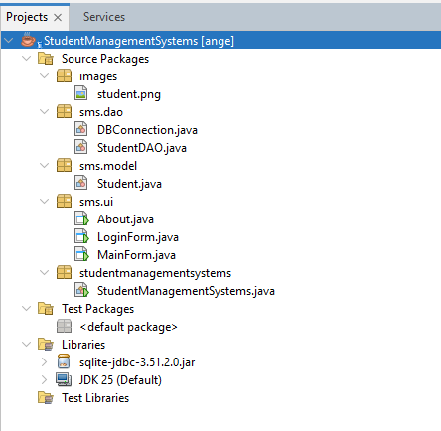
Figure 1. Simplified project structure extracted from the submitted archive.

Main files and their roles:
- DBConnection.java - opens the JDBC connection to the SQLite database.
- StudentDAO.java - performs database operations such as create table, add, update, delete, search, and sort.
- Student.java - stores student attributes such as id, name, email, gender, course, and marks.
- LoginForm.java - provides the login screen with username, password, remember me, reset, login message, and progress bar.
- MainForm.java - provides the main student management screen with form inputs, menu items, search, sort, and JTable display.
- About.java - provides a separate information window describing the application.

6. System Design and Functional Overview

6.1 Login Form
The login form contains username and password fields, Login and Reset buttons, a Remember Me checkbox, a progress bar, a message label, and a logo image. The current implementation authenticates with the credentials admin / 1234 and opens the main form when login is successful.
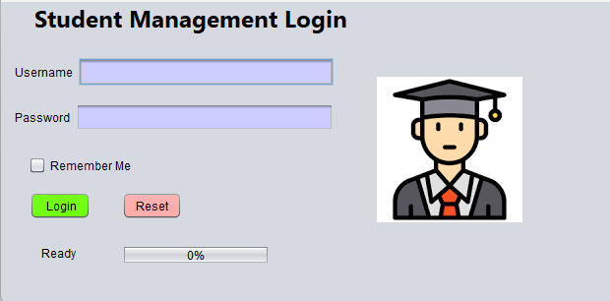
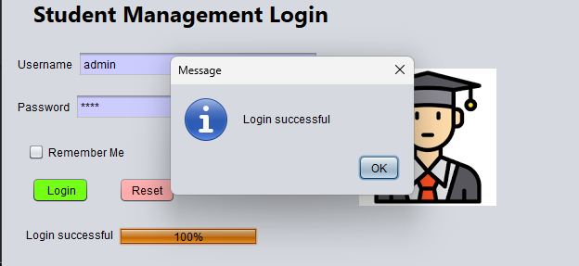
Figure 2. Login page

6.2 Main Form
The main form is the central workspace for student management. It contains text fields for ID, name, email, and marks; combo boxes for gender, course, and search category; buttons for Add, Update, Delete, Clear, Search, and Show All; radio buttons for sorting; a table for record display; and a menu bar with File, Students, and Help menus.
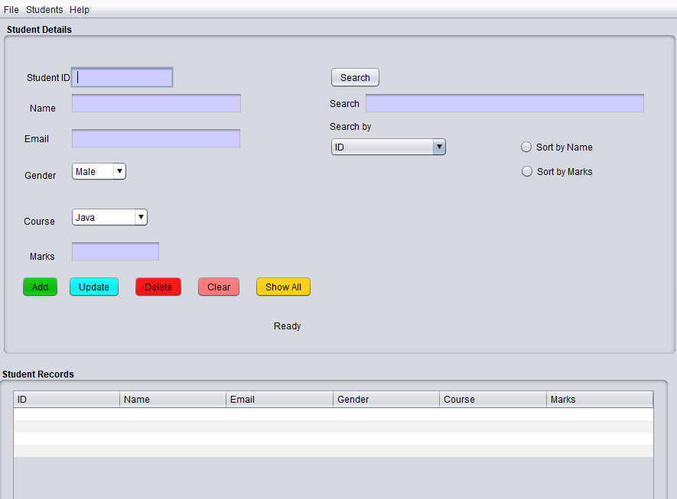
Figure 3. Main page screenshot placeholder.

6.3 About Form
The About form provides a short description of the system, its features, and the technologies used. It can be opened from the Help menu and closed independently.
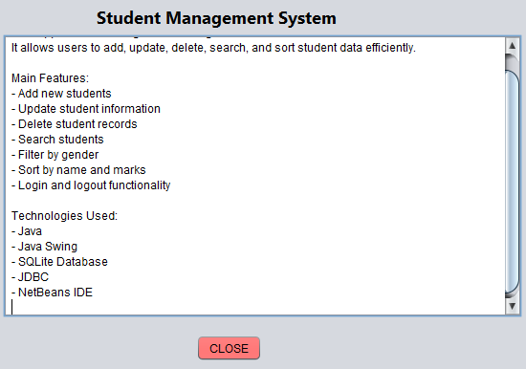
Figure 4. About page screenshot placeholder.

7. Database Design
The application uses an SQLite database stored in the file students.db. The table is created automatically if it does not exist.
Field | Description
id | Primary key used to identify each student uniquely.
name | Student full name.
email | Student email address.
gender | Gender value such as Male or Female.
course | Selected course, for example Java, DBMS, Networking, or Mathematics.
marks | Numeric scores are stored as a real value.

Sample records currently stored in the database:
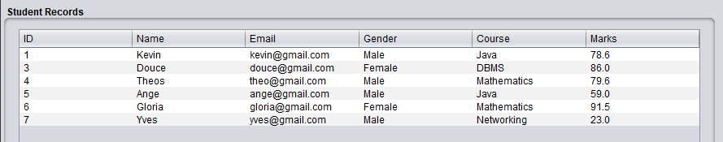
Figure 5. Sample student records found in students.db.

8. Implemented Functionalities
Function | Current behavior | Status
Login | Checks username and password, updates the progress bar, and opens MainForm on success. | Implemented
Reset login | Clears login fields, resets checkbox, message label, and progress bar. | Implemented
Add student | Adds a new record after required field and marks validation. | Implemented
Update student | Updates the selected record after required field and marks validation. | Implemented
Delete student | Deletes the selected record after confirmation. | Implemented
Show all | Loads every student record into the JTable. | Implemented
Search | Searches by ID, Name, Email, Gender, or Course using a combo box. | Implemented
Sort | Sorts student records by Name or Marks using radio buttons. | Implemented
About page | Opens a separate About window from the Help menu. | Implemented
Logout | Returns from MainForm to LoginForm and shows a success message from the file menu. | Implemented
Exit | Close the whole application from the File menu. | Implemented

9. Validation and Rules
- Add and Update operations check that the main input fields are not empty before saving changes.
- Marks must be a valid number.
- Marks cannot be less than 0.
- Marks cannot exceed 100.
- Searching by ID expects a numeric input and warns the user when a non-numeric value is entered.
- Gender search uses an exact case-insensitive comparison so typing male or female returns the correct subset.
- Name search also uses an exact case-insensitive comparison so typing KEVIN returns Kevin.
10. Conclusion
In conclusion, the submitted Student Management System successfully implements the main practical requirements of a desktop CRUD application. The project uses Java Swing for the user interface, SQLite with JDBC for persistent storage, and GitHub for version tracking. The application already supports login, add, update, delete, search, sort, logout, and an about page.

